Release Assembly - TC Cockpit Operations Dashboard Improvements 3 Deployment Guide

Revision History
Author | Revision Number | Date
Fanazhe | 1.0 | 03/24/2013

Deployment Instructions 3
1. Organization of Submission 3
2. Application Setup 3
2.1 Ant .Properties File 3
2.2 Build Scripts Setup 3
3. Database Setup 4
4. Deployment Instructions 4
5. Starting 4
6. Verification 4
7. Resource Contact List 5

Deployment Instructions

Organization of Submission

The submission follows directory structure provided below:

docs/deployment guides
Contains the Deployment Guide Document of this assembly.

direct
Contains sources and static files for Direct web application, and 3 components: contest_service_facade, project_management and project_management_persistence.
This directory replicates the application development distribution structure and includes only updated and new files.
For deployment in VM, you should use tc account to upload this folder and all subfolders to direct folder.
direct/contest_service_facade
Contains the updated java source codes for component contest_service_facade.
For deployment in VM, you should use tc account to upload this folder and all subfolders to direct/contest_service_facade folder.
direct/project_management
Contains the updated java source codes for component project_management.
For deployment in VM, you should use tc account to upload this folder and all subfolders to direct/project_management folder.
direct/project_management_persistence
Contains the updated java source codes for component project_management_persistence.
For deployment in VM, you should use tc account to upload this folder and all subfolders to direct/project_management_persistence folder.
dbscript
Contains the updated database setup files. This directory replicates the database setup project and includes only updated and new files.
Please note that if you are deploying changes of this folder in VM, you could first use tc account to upload it to /home/tc/submit, then temporarily change permission of /home/tc using “chmod 755 /home/tc”. After that, use “su informix -l” to switch to informix account, then use "cp -r /home/tc/submit/dbscript/* ~/scripts" and "cp -r /home/tc/submit/test_data_tool/ ~" to merge the submission.
test_data_tool
Contains the updated test data generate tool and sample database file.
You can use very similar way of dbscript to merge this folder. Please check guide for dbscript folder for more details.

Application Setup

The application is expected to be deployed to the following environment:

JRE 1.5
JBoss 4.2.3.GA
Informix DS 11.5

Ant .Properties File

The test_data_tool/build.properties file is modified.
Please note that if you are deploying this submission in VM, you should first change “INFORMIXDIR=/opt/IBM/informix” to “INFORMIXDIR=/opt/local/informix” and change “DBACCESS=/opt/IBM/informix/bin/dbaccess” to “DBACCESS=/opt/local/informix/bin/dbaccess”.

Build Scripts Setup
The ANT build script for the components provides the following targets which are to be used:
- dist_tcs – recompile the component and package it into jar and deployed to the direct libs directory

You need to run ant dist_tcs against the 3 updated components before redeploying direct.

The ANT build script for Direct application (build.xml) provides the following targets which are to be used:

- switch-and-checkout – checkout or switch to the defined source code branches for all components defined in subprojects.xml
- dist-backend – rebuilt all the components from the source code.
- first_deploy – must be the first task to execute from command line. It will copy all dependencies to your local JBoss folder.
- deploy – should be the main task to execute from command line. It will build and deploy WAR file.
- deploy-static-files – deploys the static files to JBOSS.
- deploy-apache-static – deploys the static files to apache server on VM.

Please refer here for more information:
http://www.topcoder.com/wiki/display/docs/TC+Direct+Setup+Guide

Database Setup
- Be sure your informix server is running;
- First you need to switch to user Informix (command: su informix -l, password: 1nf0rm1x), then please run command “JAVA_HOME=/opt/jdk1.5.0_15” and “PATH=$PATH:$JAVA_HOME/bin” to set environment parameters;
- In test_data_tool folder, run “ant generate-and-load” to generate test data and insert generated test data to database. Please note that currently VM have changed informix database name, so if you failed to run this command, please follow these 2 steps:
  - Run “ant run” to generate test data;
  - Change directory to “output”, then execute “dbaccess - generated_test_data.sql” to import the generated data.
- In dbscript folder, run “dbaccess - update_project_cost.sql” to update estimated project cost field. Please note that this step will take several minutes to finish.
- In dbscript folder, run “ant update_queries -Ddatabase=tcs_catalog” to update tcs_catalog/query_tool/ query_direct_my_pm_projects_contests_v2.txt to database (Please be aware that this step could be done later, if you are verifying ticket TCCC-5187);

Deployment Instructions

This section provides the instructions in Production environment.

- First please make sure you are using correct version of all tools. JDK version is 1.5.0_15, SVN client version is 1.6.3, ant version is 1.7.0.
- Then please make sure you are using exact the same SVN version of this submission:
SVN version of direct is 227304 (2013-04-01 15:02:42 +0800)
SVN version of contest_service_facade is 227255 (2013-03-30 05:27:11 +0800)
SVN version of project_management is 226963 (2013-03-22 23:20:23 +0800)
SVN version of project_management_persistence is 227111 (2013-03-26 18:51:11 +0800)
SVN version of database scripts is 83070 (2013-04-10 23:42:11 +0800)
SVN version of test_data_tool is 216422 (2012-05-17 21:04:04 +0800)
- Merge the code of dbscript folder and copy test_data_tool folder to folder belongs to account informix. Please follow code merge instructions from “1. Organization of Submission” and “3. Database Setup”.
- Merge the code from submission into SVN branch for Direct application and 3 components in Direct folder
- Build and redeploy the component project_management (use ant dist_tcs)
- Build and redeploy the component project_management_persistence (use ant dist_tcs)
- Build and redeploy the component contest_service_facade (use ant dist_tcs)
- Build and deploy Direct application using ant deploy (or ant first_deploy) command.
- Copy static files using ant deploy-static-files command or ant deploy-apache-static if use apache as static file server.

Starting

- Build and deploy the Direct application
- Restart JBoss server instance hosting Direct application

Verification

Verification of ticket TCCC-5187 / 4734
- Login into VM using account tc;
- Then you need to setup database and insert some test data. Please follow section “3. Database Setup” to so this, you should not run “ant update_queries -Ddatabase=tcs_catalog” now;
- Deploy Direct application. Please follow section “4. Deployment Instructions” to do this.
- Use various browsers to open the link https://localhost/direct or https://[vm_ip]/direct , login as heffan / password.

The only page should be tested is the operations dashboard page.

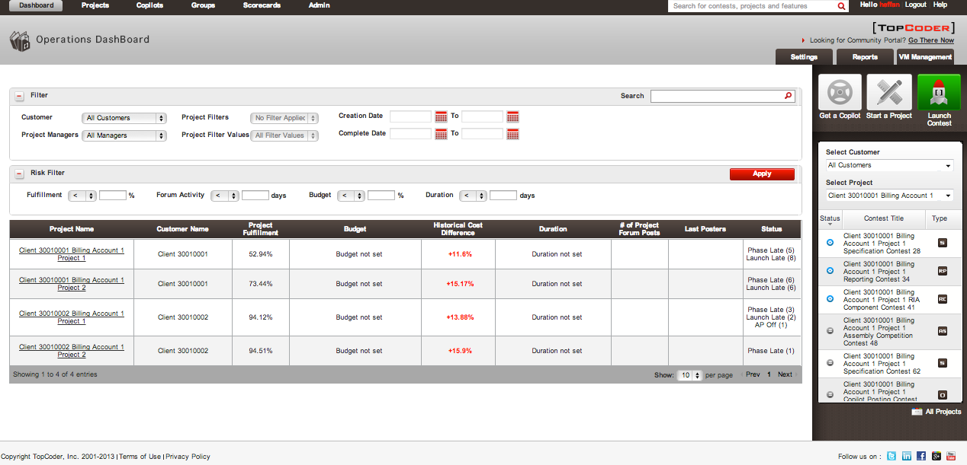
- Before execute “ant update_queries -Ddatabase=tcs_catalog” command, you should first try to open the operations dashboard page. It will take several minutes (9 minutes in a computer with 2.3GHz Core i3 CPU) to open this page.
- Then you can execute “ant update_queries -Ddatabase=tcs_catalog” command to update database query function. After update the database query function, please reopen the operations dashboard page. You will find that the operations dashboard page will take only a few seconds to open completely.
- Please follow instructions in forum (http://apps.topcoder.com/forums/?module=Thread&threadID=784721&start=0) to verify “Estimated Total Cost”. Please note that the cost calculation logic is changed so it will not be the same as the total cost in project overview page.
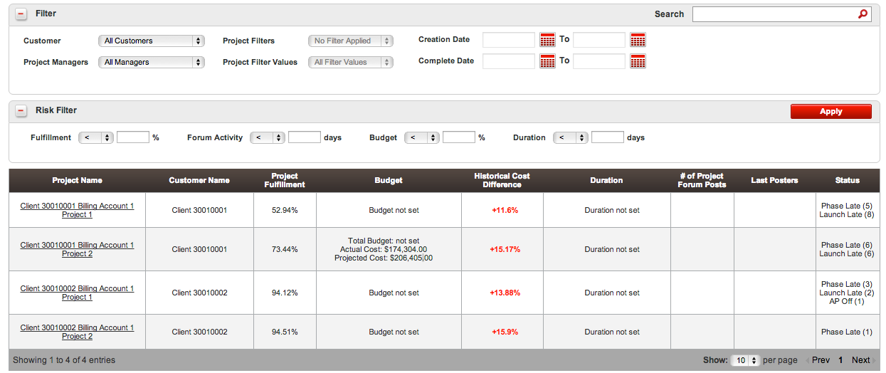

Verification of ticket TCCC-5075
- Login into VM using account tc;
- Then you need to switch to informix user to test. Please use “su informix -l” and password “1nf0rm1x” to switch to informix user. You should run command “JAVA_HOME=/opt/jdk1.5.0_15” and “PATH=$PATH:$JAVA_HOME/bin” to set environment parameters;
- Switch to dbscript folder, execute command “dbaccess - verify_5075.sql”, this will set tt_client.status=0 for client_id=30010001;
- You can verify it in operations dashboard page.

Verification of ticket TCCC-5064(5200) / 5063(5201)
- Open operations dashboard, try to select filter(s) of customer
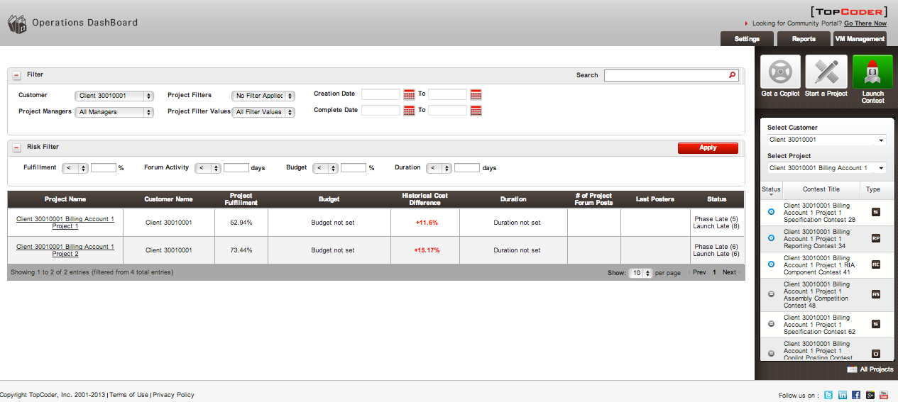

Resource Contact List

Name | Resource Email
Fanazhe | fanazhe@gmail.com

